Student Marking Application

Marc Niven Kumar
000006972

CP212, Assignment 5

Scope of Application
This application allows a user to analyze the grades of students based on a specific course and assessment. The application will generate and identify the lowest, highest, and average grade as well as the standard deviation of the grades. The application also identifies students that have failed the assessment or achieved a distinction. Lastly, it generates a histogram of the results to show the frequency of grades per assessment.

Application Interfaces
There are 3 main buttons for the user to interact with, the “Analyze Grades”, “Export Data” and “Clear Data” buttons, under the Student Marking Tab.
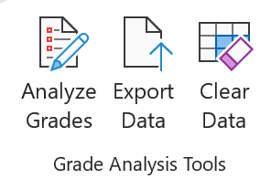

Analyze Grades
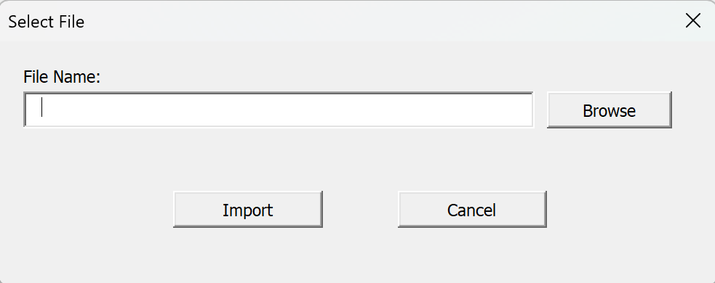
This button allows users to import the database using the userform below.

Users can browse for the file using the browse button and click import to begin selecting the desired course and assessment using the following userform.
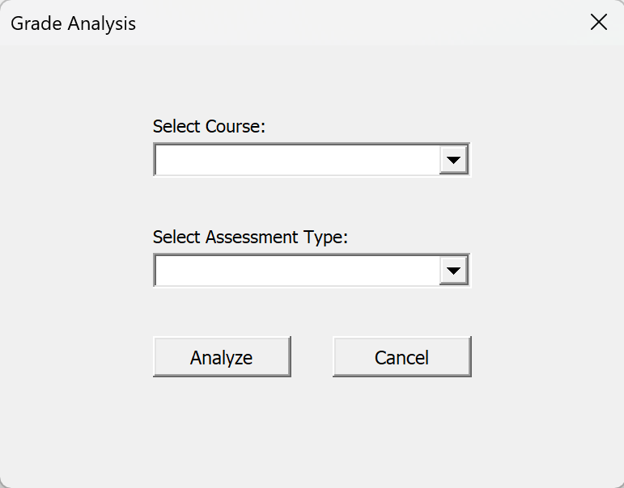

Once the analyze button is clicked, a new sheet will appear called “Grades”.
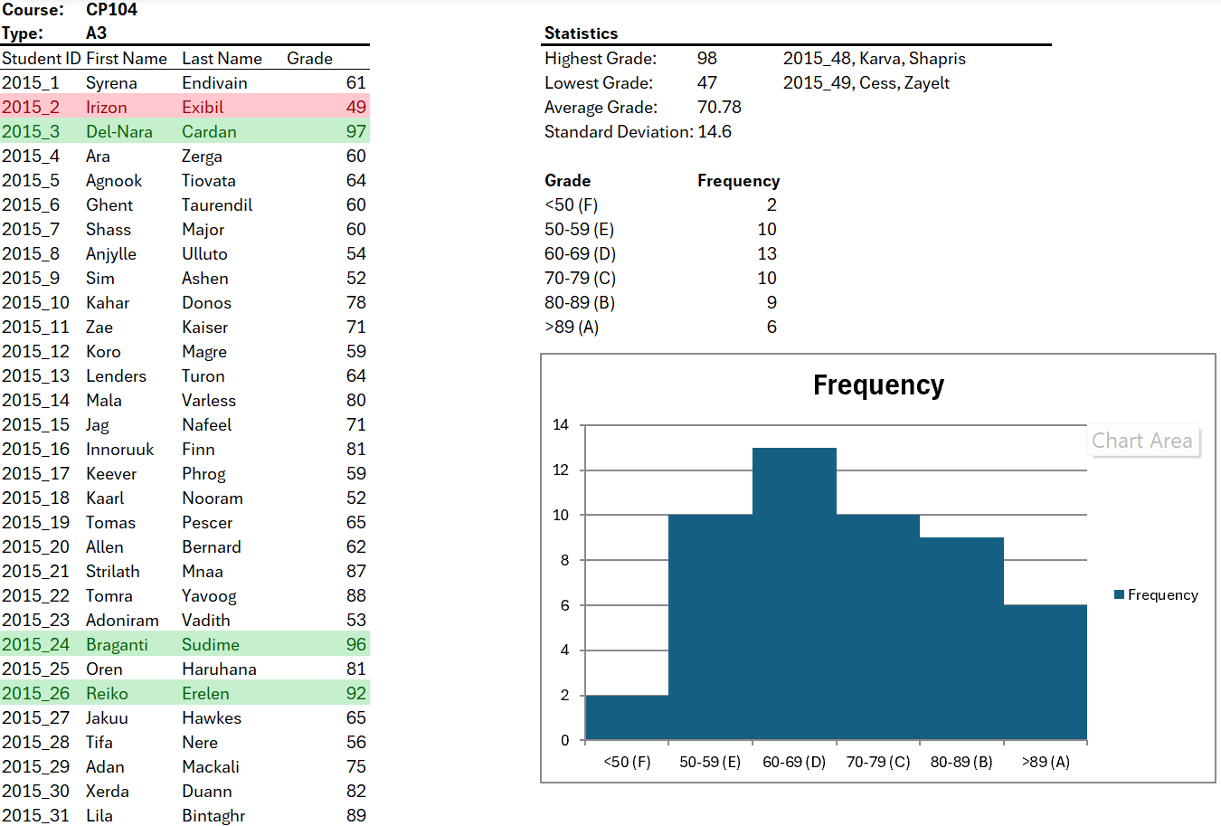

As pictured above, students that fail will be highlighted in red while students that score distinctions will be highlighted in green,
The table next to the list of students show the lowest, highest, and average grade, and the standard deviation of the grades.
Below the table is a histogram to show the frequency of each letter grade.
If the analyze button is clicked again, the user will be allowed to analyze another course or assessment and the current data sheet will be deleted.

Export Data
The export data button generates a word document that is automatically saved to the file path of the application. The document is a report of the analysis and includes the graphs and tables created from the analysis.

Clear Data
The clear data button clears the current data to start from scratch.

